Zen Assignment day 5

arrow functions

1. print odd numbers in an array

let arr = [1,2,3,4,5,6,7,8,9,10];

let odd_nums =(nums) =>{

    for(i=0;i<nums.length;i++){

        if(nums[i]%2 !== 0)

        {

            console.log(nums[i]);

        }

    }

};

odd_nums(arr);

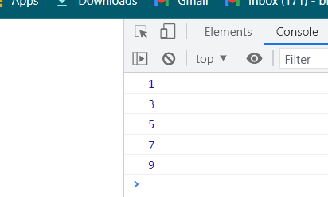

2. convert all strings to title caps in a string array.

let titleCase = (str) => {

    return str

        .split(' ')

        .map((word) => word[0].toUpperCase() + word.slice(1).toLowerCase())

        .join(' ');

}

console.log(titleCase("this is an arrow function"));

Ans :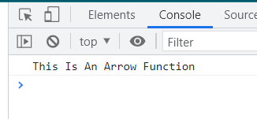

3.sum of all elements in a Array

let arr = [1,2,3,4,5,6,7,8,9,10];

let sum =0;

let sum_of_array =(num) =>{

    for(let i=0;i<num.length;i++)

    {

    sum+=num[i];

    }

    console.log(sum);

};

sum_of_array(arr);

Ans;

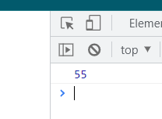

4. Return all the Prime numbers in a array.

let sumPrimes = (num) =>{

    let numArray = [1,2,3,4,5,6,7,8,9,10,11,12,13,15,16,17,18];

    //Remove non-prime numbers from the array

    numArray.map((number) => {

      for (let i = 2; i < number; i++) {

          if(number % i === 0) {

              let index = numArray.indexOf(number);

              return numArray.splice(index, 1);

          }

      }

    });

   return numArray;

  }

  console.log(sumPrimes(10));

ans

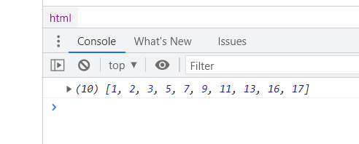

5. Return all the palindromes in an array

let array_strings= ['kaushik', 'nan','anna','ray','level','refer','look'];

let find_palindrome =(str) =>{

    for(i=0;i<str.length;i++){

let strReverse = str[i].split("").reverse().join("");

if (str[i] === strReverse) {

 return str[i] ;

}

}

return str[i];

};

console.log(find_palindrome(array_strings));

Do the below programs in anonymous function & IIFE

1)Print odd numbers in an array

|  |
| --- |
| ans; |
|  | //using IIFE |
|  | let arr=[1,2,3,4,5,6,7,8,9,10]; |
|  |  |
|  | (function () { |
|  | for(let i=0;i<arr.length;i++){ |
|  | if(arr[i]%2!=0) |
|  | console.log(arr[i]); |
|  | } |
|  | })(); |



2.Convert all the strings to title caps in a string array

|  |
| --- |
| Ans |
|  | function titleCase(str) { |
|  | return str |
|  | .split(' ') |
|  | .map((word) => word[0].toUpperCase() + word.slice(1).toLowerCase()) |
|  | .join(' '); |
|  | } |
|  | console.log(titleCase("this is an anonymous function")); |

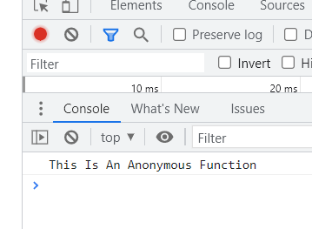

3.Sum of all numbers in an array

|  |
| --- |
| //using IIFE |
|  | (function () { |
|  | let arr=[5,5,5,5]; |
|  |  |
|  | let sum=0; |
|  | for(let i=0;i<arr.length;i++) |
|  | { |
|  | sum+=arr[i]; |
|  | } |
|  | console.log(sum); |
|  |  |
|  | })(); |

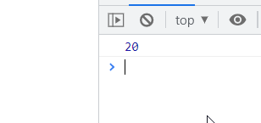

4.Return all the prime numbers in an array

 (function (num) {

    let numArray = [1,2,3,4,5,6,7,8,9,10,11,12,13,15,16,17,18];

    //Remove non-prime numbers from the array

    numArray.map((number) => {

      for (let i = 2; i < number; i++) {

          if(number % i === 0) {

              let index = numArray.indexOf(number);

              return numArray.splice(index, 1);

          }

      }

    });

   return  console.log(numArray);

  })(10);



5 Remove duplicates from an array

let chars = [2,3,2 ,5,6,6,7,8,9];

let uniqueChars = chars.filter((c, index) => {

    return chars.indexOf(c) === index;

});

console.log(uniqueChars);

